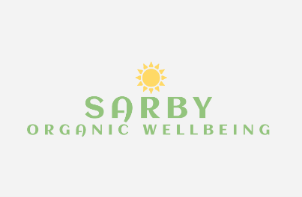

Energy Healing Retreat

in the Heart of Sri Lanka's Lush Hills with Sarby
Oct 6 – 12, 2023
Hello Earthlings,
Thank you so much for your interest, for booking please follow the link below.
There are instalment payment options in place including deposit and one time payment with 0% interest
Any questions, please do drop me an email

Booking: Energy Healing in the Heart of Sri Lanka's Lush Hills with (tourhero.com)
Email: sarbyorganicwellbeing@gmail.com
Instagram: https://instagram.com/sarbyorganicwellbeing

Book now to secure your spot

