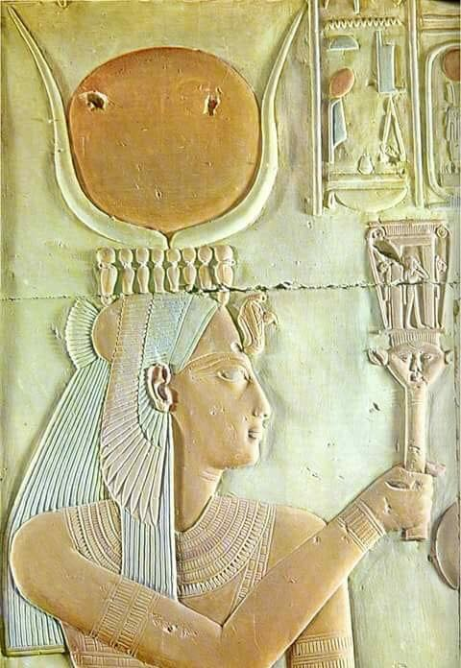
Goddess Tour to Egypt III
22 November 2018
to 6 December 2018

T

Michelle Leske
awakenthegoddess.info
leskemichelle47@gmail.com
+2782 378 5859
I am delighted to bring forward the third goddess tour to Egypt. the first two tours were amazing and the third will be even better.
The intention of the Goddess Tours is for participants to experience personal growth. healing areas in your life that are holding you back, and learning to surrender into a space of peace and knowing that there is divine timing for everything. learning that the only thing that you can control in your life is your attitude towards it, and the deep understanding that there is a divine plan for all of us. timing is crucial and once you have done the work and made progress on a personal and spiritual level, your life will become a manifested miracle.
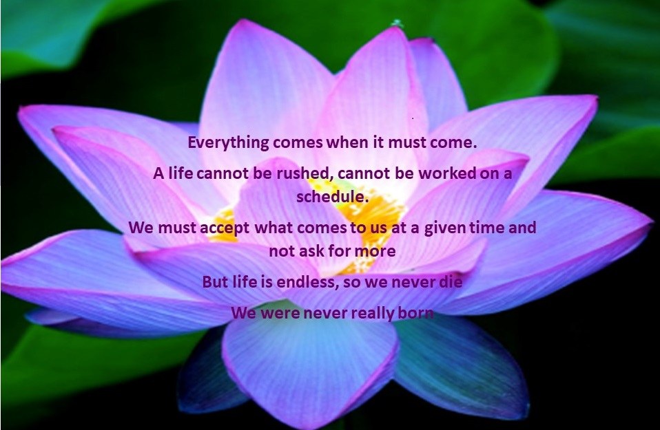I have chosen Egypt as the destination to assist others to heal because of the personal growth and healing I have experienced there. The temples hold ancient keys to unlocking your magnificence, the goddesses of healing are there to assist us to move forward and let go of any stuck emotions that are no longer serving us and the river Nile herself assists hugely in the cleansing process.
Have you been called to attend this healing journey?
If so, please see the itinerary for further information on this tour.
the itinerary

Day 1
22 November (Thursday)
Meals Included: BLD
- Transfer from the Airport, check into Hotel (Pyramids Valley Inn)
- Giza is the home of the Third Eye Chakra. The Third Eye Chakra is seated in the centre of the forehead and when functioning properly enables intuition, clairvoyance, clairaudience and clairsentience. The All Seeing Eye. Throughout this tour we will work on the Third Eye Chakra by meditating and being still, allowing our intuition to develop.
- Opening Ceremony
- Sphinx (Private Visit)
The Sphinx is also known as Tefnut, the first Lion Headed Goddess and the very first Mother.
Tefnut was the daughter of Ra and she was the Goddess of the Moon and Moisture and also the Goddess of the Sun and dryness. She was also the Eyes of Ra, the Sun God. Tefnut and her Brother Shu, were the first ones created ever, from them humanity came forth.

We are honoured to have special permission to sit between the paws of the first Mother. To experience her nurturing and healing. A special time to be experienced by all.

- Regrouping at the hotel to discuss our experiences at the Sphinx
- Dinner
- Overnight Cairo
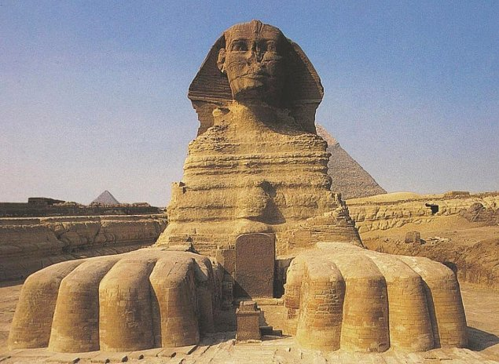
Day 2
23 November (Friday)
Meals Included: BLD
- Meditation and Mantras in the morning after breakfast
- Explore the area around the Giza Plateau
- In the late afternoon we will have Private Entrance into the Pyramid with meditation and sound healing
- The Pyramids are believed by some to be tombs of Pharaohs. This is not actually the case at all, when you are inside the pyramid you will begin to understand that these wonders were in fact built for an entirely different purpose. We will also discuss how the Pyramids were built.
- Overnight Cairo
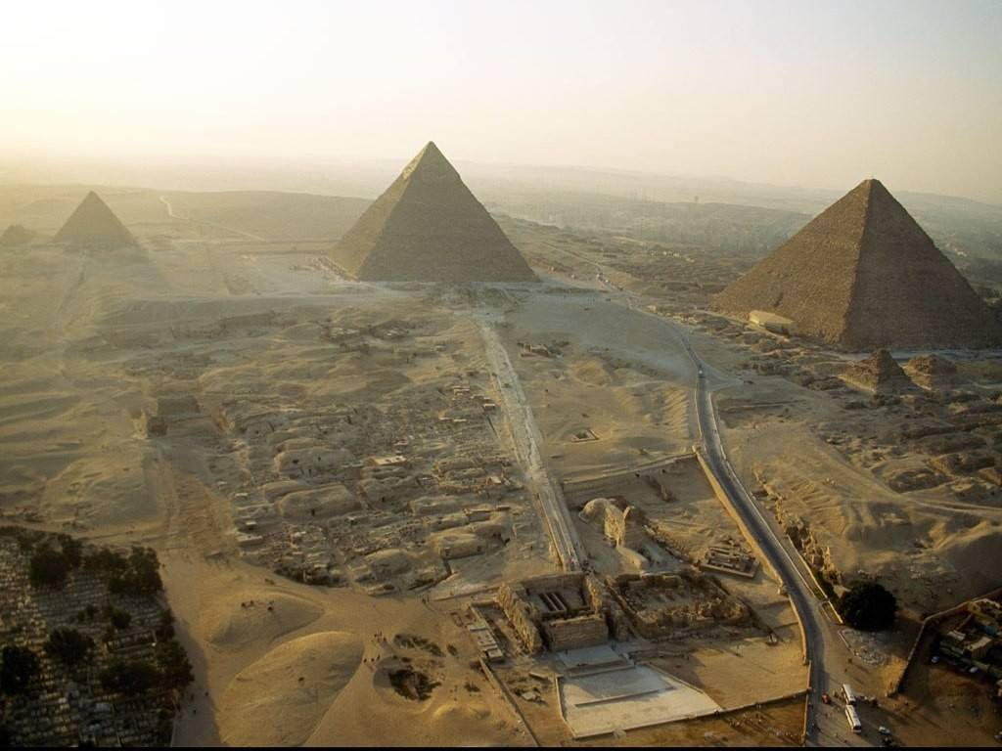

Day 3
24 November (Saturday)
Meals Included: BLD
- Fly to Abydos early morning
- Check into the House of Life and unpack
- Meditation and Mantras. Abydos has a Star Gate and thus the energies here in this village are heightened, if we use these energies with good intent and intention, our healing will be more effective.
- Private healing sessions throughout the day at the House of Life Healing Center. Please see the last page of this itinerary for a complete list of what is available.
- Private Visit to Abydos Temple in the late afternoon (Private Visit Abydos Entire complex with meditation).
The original temple in Abydos was built for the God Osiris, his head is buried here and you will have an opportunity to be in this sacred space. The temple built on top of the original temple to Osiris is the temple dedicated to Seti I.
We will have the opportunity to explore the Osirion, which is closed to the general public and also do a walk of Resurrection and Rebirth during our private access.
Abydos Temple was a Healing Center for Ancient Egyptians, they did everything possible to go on a Pilgrimage to Abydos at least once their lives. If they didn’t make a pilgrimage in their lifetime, they would have a Stelae (a tablet with a message from a person) placed there instead.
Abydos is indeed a very Holy place and great transformation is possible here.

- (Overnight House of Life Abydos) Please see their website for more information and healing modalities that will be available to our group during our stay there:
http://houseoflife.info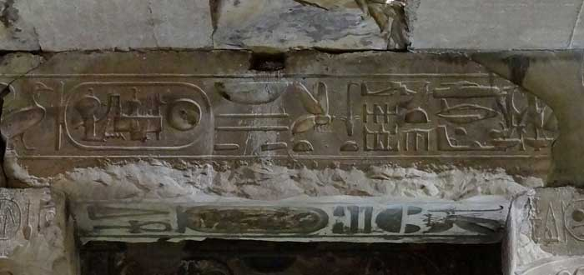
Depictions of space craft, aeroplanes and helicopters in the Temple of Seti I at Abydos

Day 4
25 November (Sunday)
Meals Included: BLD
- Morning Mantra and Meditations
- Visit Ramses II Temple
- Free time during the day to make use of the facilities at the House of Life. As per list on the bottom of this document.
(Overnight House of Life Abydos)
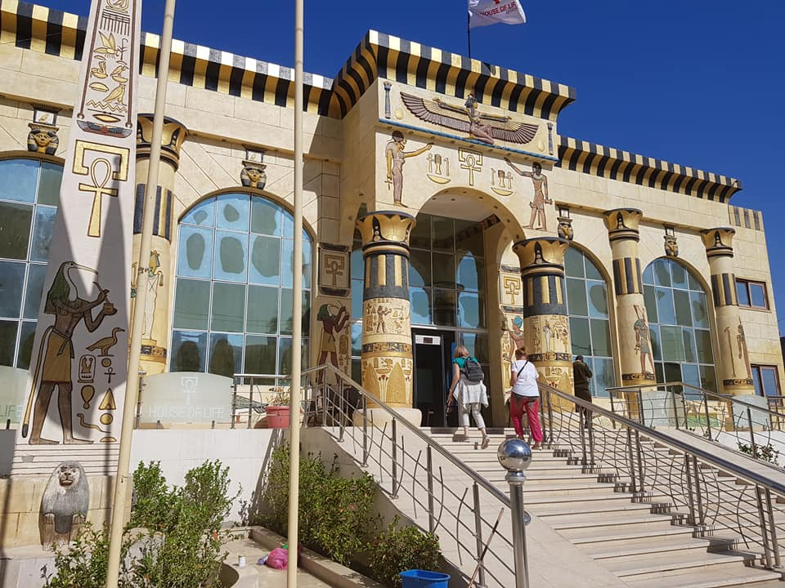
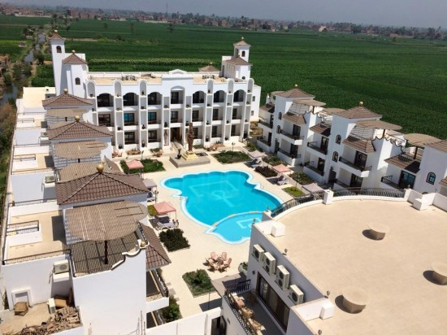
Day 5
26 November (Monday)
Meals Included: BLD
- Free day of Healing and Meditation, group and private, or you can choose any of the healing modalities or excursions that the Hotel has to offer (see details at the end of this document)

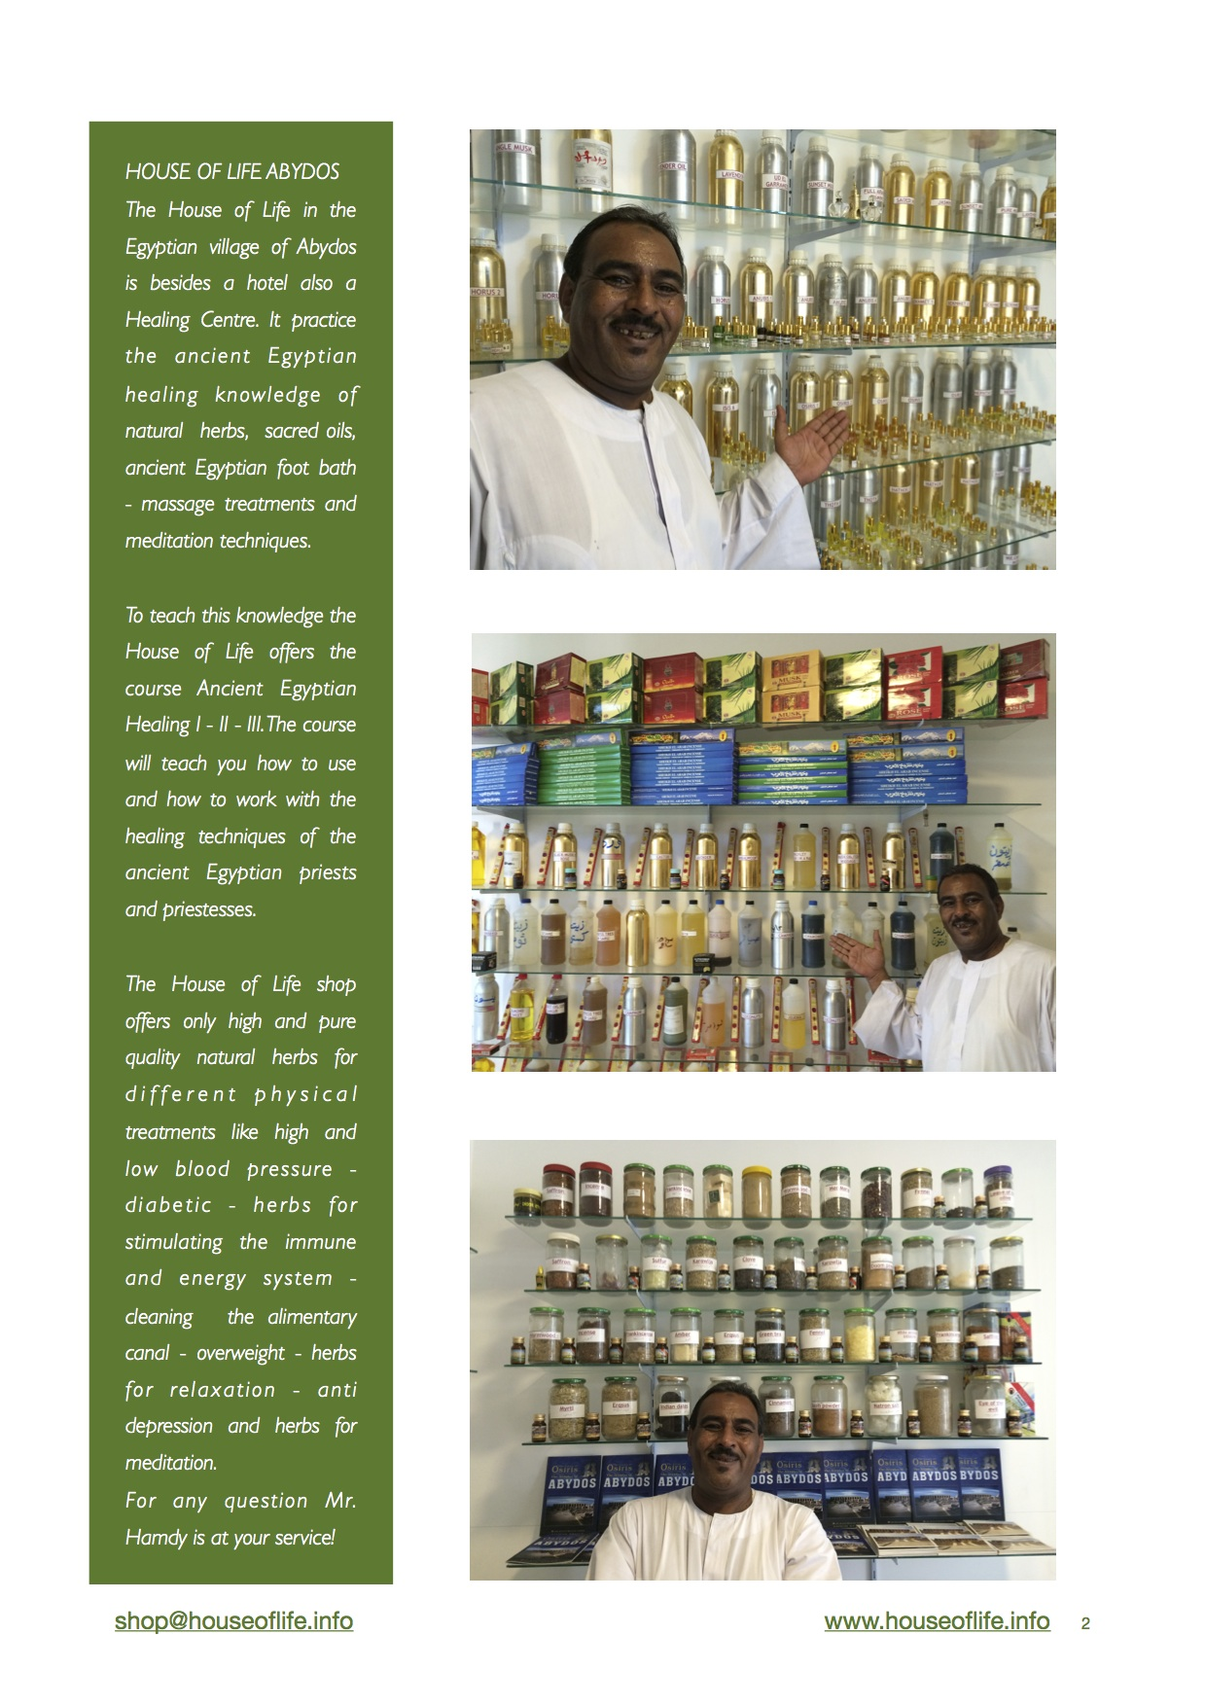

Day 6
27 November (Tuesday)
Meals Included: BD
- Depart from Abydos and Travel to and visit Dendara Temple
Dendara Temple is dedicated to the Goddess Hathor. She is the Goddess of all things wonderful: joy, dance, love, alcohol, music and a protector of mothers. She is often depicted as a cow headed goddess with cow like ears.
We will see the very first depiction of the zodiac in this temple. Dendara temple has the most magnificent colours of all the temples in Egypt, it is going through a restoration process, with years of smoke and dust being cleaned off the walls and the colours being exposed, it is breathtakingly beautiful.
We will also have the opportunity to do a private meditation in the Chapel of Isis, connecting
to your heart centre and eternity
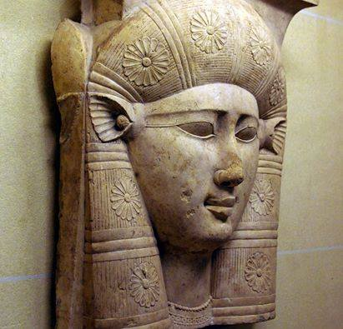
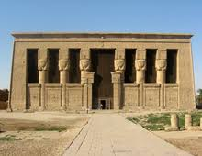
- Travel to Luxor stopping for lunch on the way (at own expense) and board the Dahabiya
Dahabiyas, river-going sailing ships, were common in Egypt in the early 1900s when sophisticated travellers loved to cruise the Nile in comfort. They made their way down the Nile enjoying the river breeze. To this day the dahabiyas are popular among those who wish to enjoy Egypt at a leisurely pace, to take in the landscapes, view the ancient treasures and life on the riverbank.
There has been a revival of dahabiyas and you can now travel in modern comfort.
The experience of sailing the Nile on a dahabiya fulfils dreams and is quite different from traveling on a floating hotel like a cruise ship. The dahabiya experience is a privilege both romantic and intimate. Feel the wind in your hair, float along, and the only sound you’ll hear is the wind in the sails, children laughing on the riverbank.
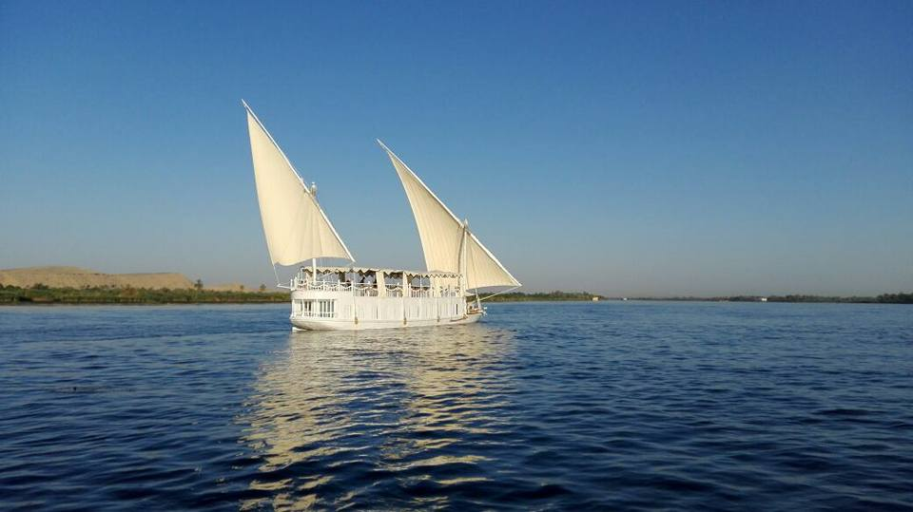
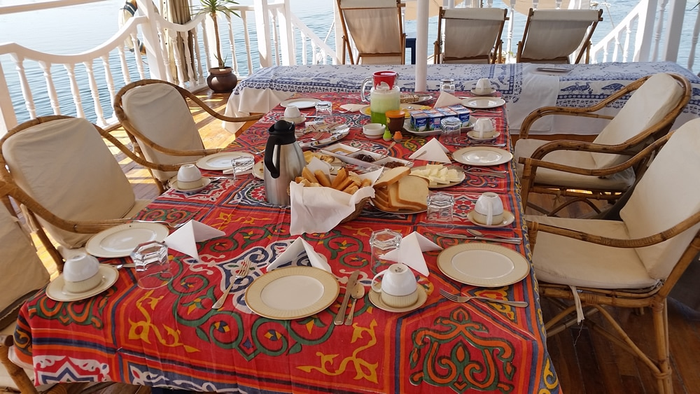
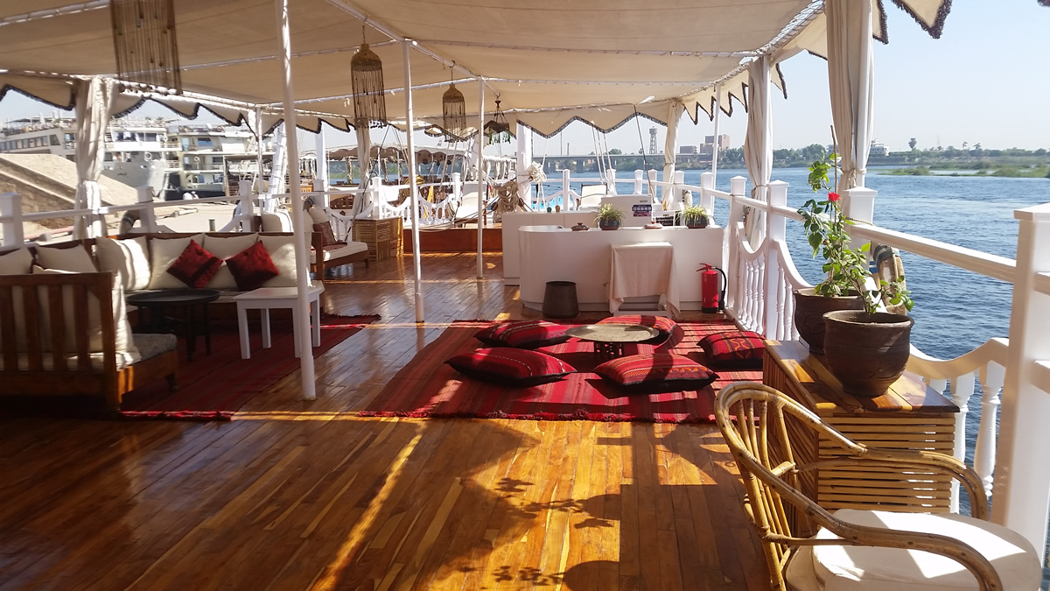
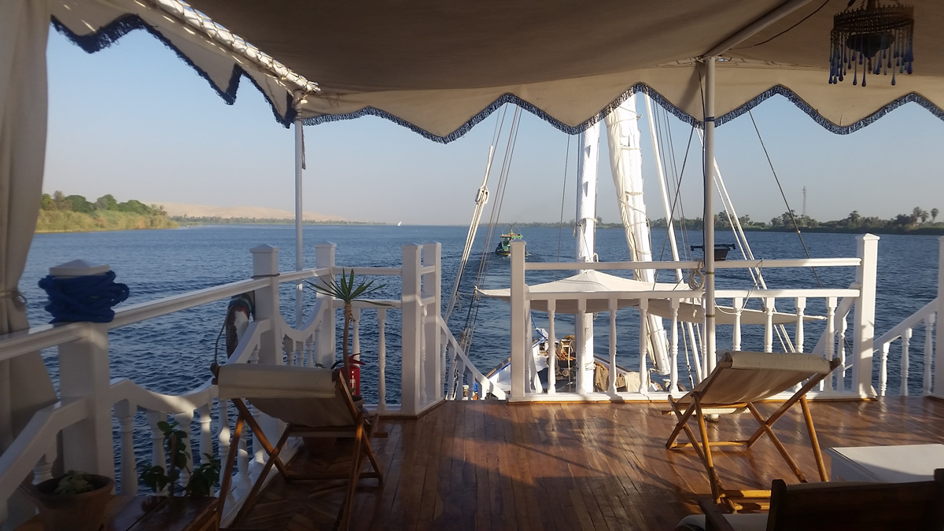

- Free time to unpack and settle on to the Dahabiyas (we will have twin Dahabiyas to accommodate our group) which will be our home for 7 nights
- Evening Meditation and Water Ceremony
- Luxor is the Heart Chakra of Egypt, so this is a wonderful opportunity to release any sadness, grief, or other blockages, so that we may experience Pure Divine Love.
The Ascension Flame is housed over Luxor. It is kept by the Ascended Master, Serapis Bey, who was charged to bring the Flame to Luxor from Atlantis before Atlantis sank. This tour is a perfect time to work on your Ascension Process, to become a Master of yourself, to learn about the different Flames and their purposes.
- Overnight Dahabiya

Day 7
28 November (Wednesday
Meals Included: BLD
- Karnak Temple at Sunrise
One of the highlights of visiting Karnak Temple, will be the opportunity to have private time in the Chapel of Sekhmet. Sekhmet is another lion headed goddess and she is the destroyer of the ego. She will assist those who are open to it, to start operating more on a soul level, and move into a space of surrender. No person, can be in her presence and not be affected by her magic. Although this is a statue, please bear in mind, that every statue, every temple and every area of Egypt, holds sacred keys to assist us on our spiritual journey.

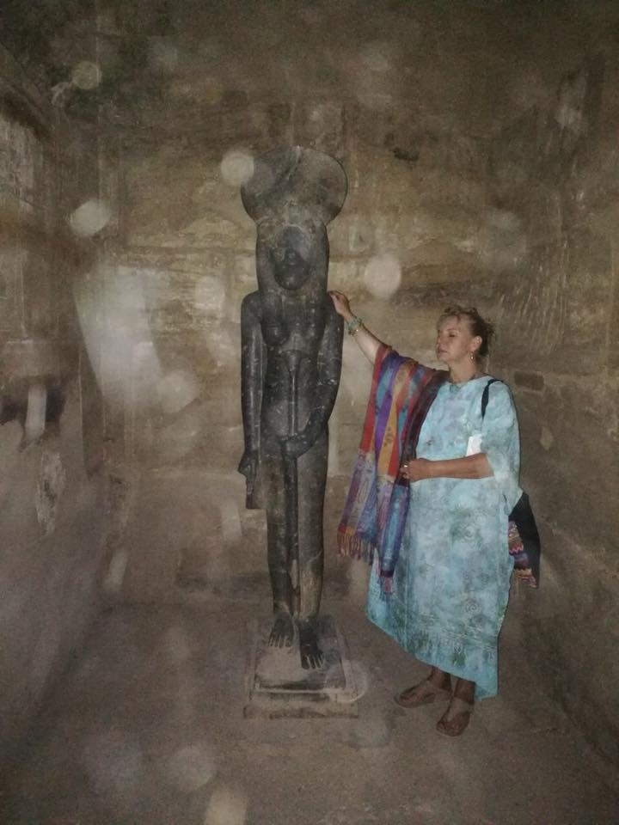
Being in the presence of Sekhmet is a wonderful liberating experience.
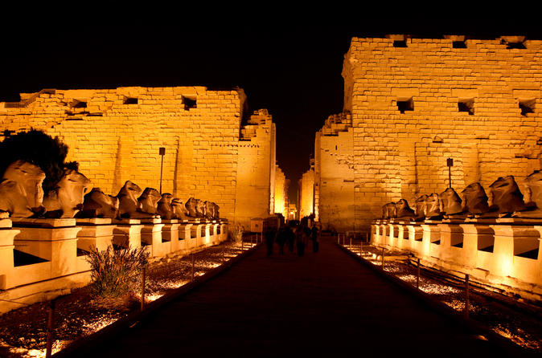

Karnak Temple at night with the Avenue of Ram Headed Sphinxes which leads to Luxor Temple

- We will return to the Dahabiya and reflect on our time spent with Sekhmet
- Mantras and Meditation to release what is no longer serving us
- Luxor Temple in the Evening

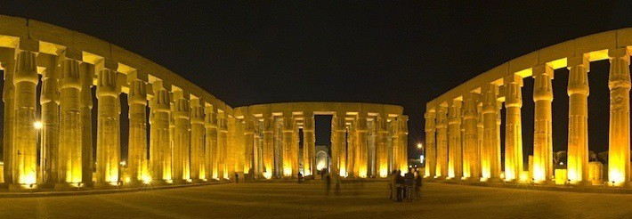

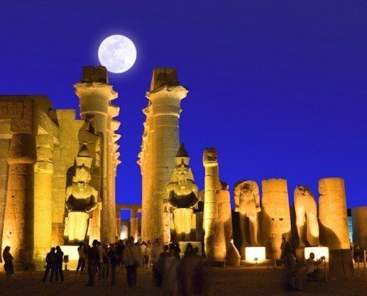
- Overnight Dahabiya

Day 8
29 November (Thursday)
Meals Included: BLD
- Hatchepsut Temple at Sunrise
Hatchepsut was one of the few Female Pharaohs. Her Temple is very unique and varies from other temples in its design, although it was mostly destroyed by her son, who wanted to destroy any evidence of her reign, there is still quite a lot to see here. The Holy of Holies has recently been opened to the public again, and we are privileged to be able to do a sunrise meditation in this space today.

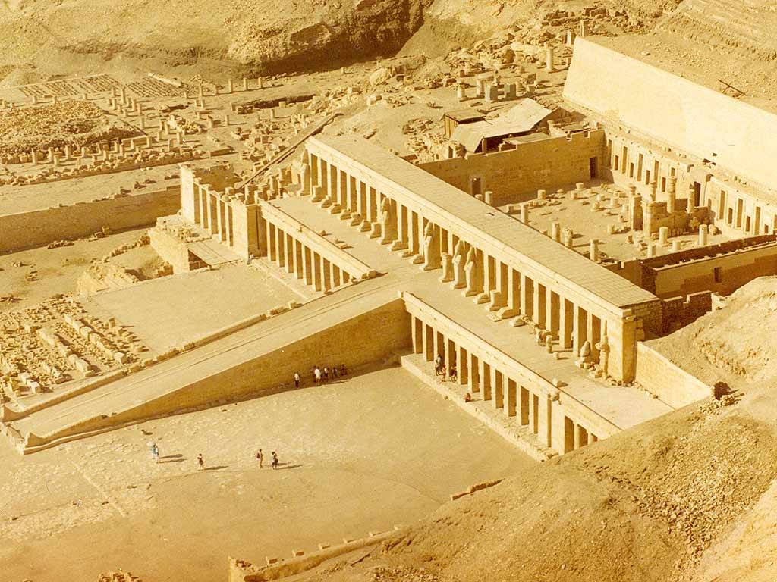
- Visit Valley of the Queens
The Valley of the Queens houses the Tombs of amongst others, the most exquisite tomb of Nefertari, the Beautiful One. She was the most beloved wife of Ramses II. We will visit this tomb, which requires an extra ticket and is an optional choice for you. Only 150 people a day may visit this beautiful tomb, which has only recently been opened to the public. The feeling of peace and beauty which can be experienced in this very well preserved tomb is almost surreal. We will also visit another 3 tombs in the Valley of the Queens. Scenes of daily life, and the depiction of how Spirituality was part of the daily life and ritual of the Ancient Egyptians, can be witnessed on the beautiful wall paintings. Be prepared to be amazed.
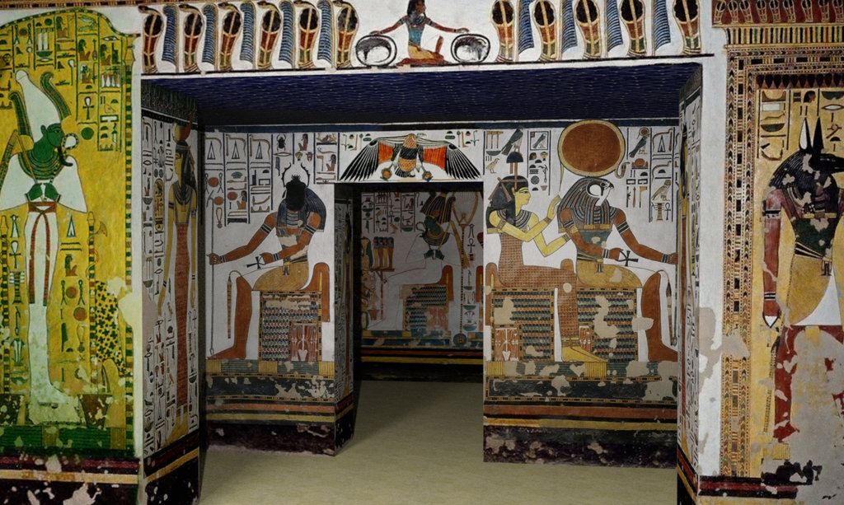

- Travel to Esna and sail through the Loch. This is an interesting time on the Dahabiya, when the High Dam was built, the levels of the Nile River changed. The boat has to be lowered in order to continue sailing the Nile.
- We will do some mantras in the evening, to express our gratitude for the day

- Overnight Dahabiya

Day 9
30 November (Friday)
Meals Included: BLD
- Meditation and Group healing in the morning, connecting with and exploring Christ Consciousness. Working on the Solar Plexus Chakra and Divine Love
- Sail to El Kab and visit the village to see the ancient city
- Sail to Edfu Visit Edfu Temple
- Esna and Edfu house the Solar Plexus Chakra. This is where we store fear, when in a negative state. Now is the time to release the fear that is holding you back from Divine Love, Creativity and Manifestation of an abundant life.
- Edfu Temple is dedicated to the God Horus. Edfu temple is one of the most beautifully preserved Temples in Egypt.
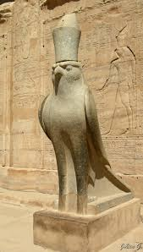
Horus
The Falcon Headed God

- Overnight Dahabiya

Day 10
1 December (Saturday)
Meals Included: BLD
- We continue working on the Solar Plexus Chakra, our Sun Center. Meditations and Mantras to assist with releasing
- Visit a local Village while sailing all day
- Overnight Dahabiya

Day 11
2 December (Sunday)
Meals Included: BLD
- Visit Gebel el Silsila which is a fascinating site that contains tombs, stelae of Pharaoh’s and granite quarries from where stone was obtained to create temples, including the Ramesseum.
- Meditation and Mantras and Self-Love exercises, whilst sailing the Nile
- Overnight Dahabiya
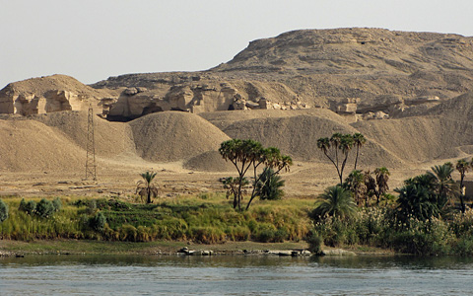
Gebel El Silsila, a place where very few tourist go. We are fortunate to have this opportunity, since the Dahabiya can reach places where other cruise boats cannot. Blessed Indeed!

Day 12
3 December (Monday)
Meals Included: BLD
- We will sail to Kom Ombo
- The Seat of the Soul Chakra is at Komombo. This is the Chakra, which when in alignment, allows us to express our Divine creativity. We are all talented, and each one of us has a unique talent. What a wonderful opportunity to unblock this Chakra, and allow Divine Creativity to flow…………………..that’s what Goddesses do! Bring into Manifestation, that which the Divine Creator has created.
- We will connect with our creative centre and possibly discover our true potential in this life. Meditations and Mantras, will assist us to reach a space of heart centeredness.
- Visit Kom Ombo Temple where we visit the twin temples, one dedicated the god Horus and the other to the crocodile god Sobek.

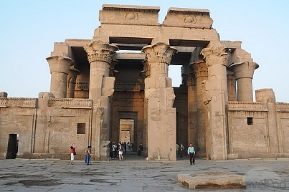
- Visit a Camel Market and experience trading of camels, something that we may never experience again
- Sail to Aswan and then travel by coach to Abu Simbel
- Overnight Abu Simbel

Day 13
4 December (Tuesday)
Meals Included: BLD
- Visit Abu Simbel at Sunrise. A meditation in the Holy of Holies, with the sun of the new dawn blessing us and giving us the strength and energy to move forward into a space of Divine Love.
- Abu Simbel is the Base Chakra of Egypt. Here we will meditate on issues like Power, Money, Feeling safe and grounded and connected to the Physical world.

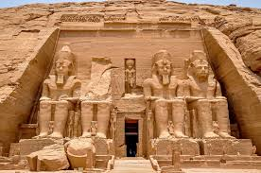
Abu Simbel Temple, dedicated to Ramses II. This temple had to be moved from its original location when the High Dam was built.

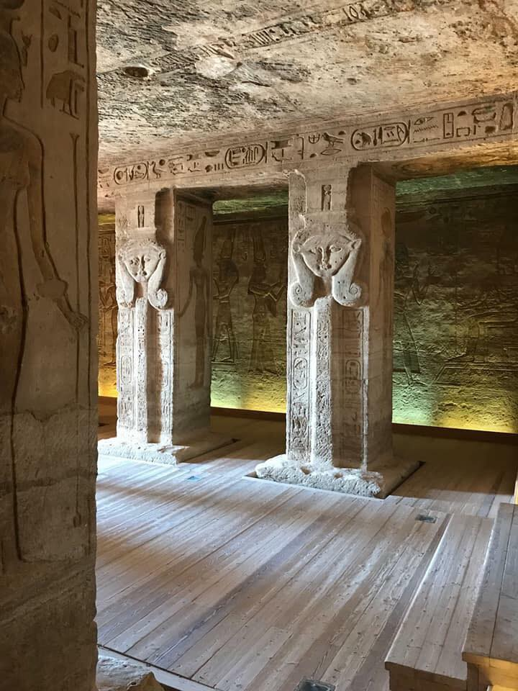

Inside the Temple built to honour the Beautiful Nefertari. This was commissioned by her husband, Ramses II to honour his beloved wife.

- Travel back to Aswan

- Visit Philae Temple in the afternoon
Philae Temple is dedicated to the Goddess Isis, sister/ wife of the god Osiris.
Here we will invoke Isis to work with us to balance the dominating Masculine energy that we are holding and allow for more of the Feminine Energy to be activated.
Philae Temple was also relocated when the High Dam was built, and it now sits on an island, that is lush with natural vegetation and bird life.
We will also visit the original site of Philae Temple, and do a meditation on the waters of the Nile close to the original site of the temple.
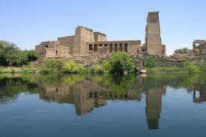

- Overnight Dahabiya

Day 14
5 December (Wednesday)
Meals Included: BD
- Fly to Cairo
- Check into Hotel in Cairo (Pyramids Valley Inn)
- Visit Saqqara
Saqqara is home to the Step Pyramid, the oldest of the 97 pyramids in Egypt, the Hospital and Healing Center, and also the Serrapeum. Much evidence is left to show us how sound was used for healing the physical and emotional bodies. This is a massive complex, and we will have plenty time to explore and bask in the energy of the area and experience some healing ourselves.
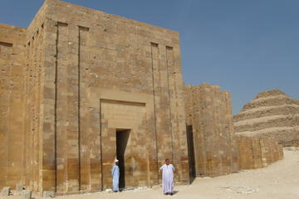

The Healing Hospital at Saqqara. We will witness how Sound Therapy was used for Healing, and also experience this ourselves.
We will stop for lunch (your own expense) on the way to Abu Sir
Abu Sir is home to the Sun Temple. It is not open to the public, so we will have the whole area to ourselves, to do some meditations and exploring of our journey thus far. This area is also a Star Gate and a portal for Ascension. We are honoured to be present in this Holy Space.
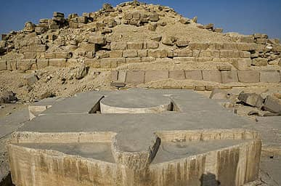
Overnight Cairo
Day 15
6 December (Thursday)
Meals Included: BD
- Visit the Museum in the morning
- Lunch at own expense
- Visit The Virgin Tree
The Virgin Tree is a place where Mary and Joseph took refuge from King Herod. It is believed that a spring of water appeared to wash the baby Jesus. Many Coptic Christians make Pilgrimages to this area, to receive blessings. Many pilgrims believe that, because of the tree's direct link to Christ, it contains miraculous properties and that when touched it can help to heal the sick.
- We will have our closing ceremony in this Holy Place to end our journey of self-discovery and healing our heart centers.
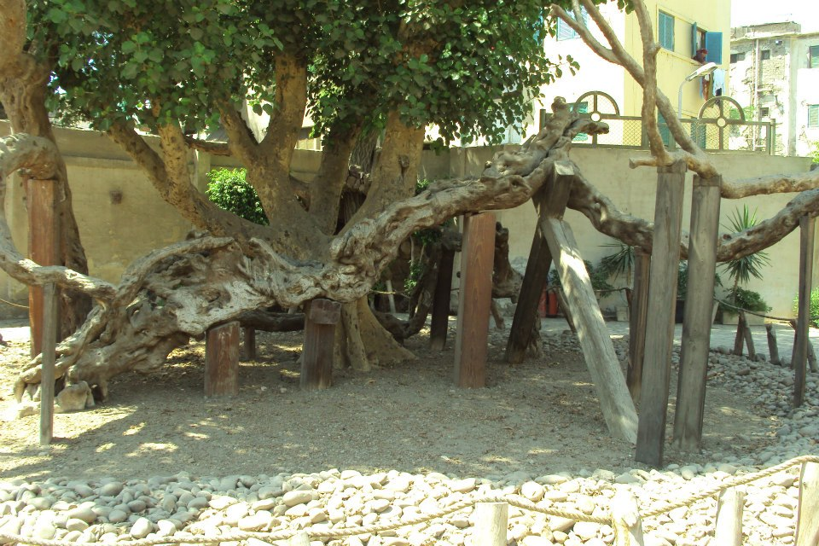

- Late Check out of Hotel and transfer to Cairo International Airport to fly home

Price: US$ 2990 per person sharing in a Double Room
US$ 3340 if you prefer a single room

A non-refundable deposit of US$ 500 is required to confirm your space

Payment information:
A non-refundable deposit of US$500 is payable on booking
SUGGESTED PAYMENT METHOD:
Per Person Sharing Single Room
a Double Room (Supplement)
Payment Date Amount Amount
Deposit on Booking US$ 500 US$ 500
31 May 2018 US$ 458 US$ 528
30 June 2018 US$ 458 US$ 528
30 July 2018 US$ 458 US$ 528
31 August 2018 US$ 458 U$ 528
1 October 2018 US$ 458 US$ 528
Tipping to be paid
On arrival in Egypt US$ 200 US$200
TOTAL US$2990 US$3340

It is possible to pay the full amount on booking, if that is what you prefer.
Payments are to be made to:
My PayPal account: mmleske@mweb.co.za (You may use this account if you wish to make payments using your credit card). Please add 4% if you are using this payment method.

Or into my banking account below:
M. Leske
First Rand Bank
Cheque Account
Account Number: 626 6595 3438
Branch code: 254005
Swift Code Number: FIRNZAJJ

Package includes:
- All sightseeing tours throughout (including entrance fees) with a private licensed bilingual speaking guide.
- All transfers in a/c vehicle as stated in the program. Including airport transfers
- All tips to staff and hotels (You may want to add to the tip for our wonderful guide, but that is entirely optional)
- All meals mentioned in the itinerary. You would only need to pay for 3 lunches
- On the Dahabiya, all soft drinks, fruit juices, mineral water, fruit and snacks are available throughout the day and are included in the cost. Alcohol consumed on the Dahabiya needs to be paid for separately.
- 4 Nights at the Pyramids Valley Inn in Cairo
- 3 Nights at the House of Life in Abydos
- 1 Night at Tuya Hotel in Abu Simbel
- 7 Nights on the Dahabiya
- Domestic flights in Egypt, (Cairo to Abydos/Sohag) and (Aswan to Cairo)
- Entrance into the Paws of the Sphinx (Not open to the Public, special permission and payment arranged by the agent) Included in the price.
- Private Entrance into The Great Pyramid Included in the price.
- Private Entrance into Abydos Temple Included in the price.
- Private entrance into Abu Sir Temple (Not open to the Public, special permission and payment arranged by the agent) Included in the price.
- Meditations in areas mentioned in the itinerary, special permission and extra fees have to be paid for this privilege, and the cost is included in the price.

Package excludes:
- International flights
- Egypt Entry Visa (free for South Africans)
- Any optional excursions.
- Personal expenses such as drinks, tips, laundry, telephone calls, etc.
- Any meals not mentioned in the itinerary (8 lunches)
- Travel Insurance

Optional Excursions:
Optional Entrance into Nefertari Tomb – US$100
Hot Air Balloon Ride – US$100
Sound and Light Show Abu Simbel – US$35
Sound and Light Show Karnak – US$ 35
Sound and Light Show Sphinx – US$35
Sound and Light Show Philae Temple – US$35

House of Life Optional Treatments:
The following treatments are always available during your stay in the House of Life:
1. Ancient Egyptian body massage ‘The massage of the Ba’. This treatment with the sacred ancient
Egyptian massage oils will give relaxation to your Ba, the Light of your Soul. Fee: € 35, 0r $ 40

2. Ancient Egyptian feet bath. This treatment is to open the energy points under your feet to
stimulate the natural energy flow inside your body. Fee: € 15, or $ 18

3. Groups or Individual Healing meetings with Horus from Abydos. During this meeting Horus will
work with your personal issues and questions in relation to the ancient Egyptian Healing
knowledge.
Fee Individual: € 50, or $ 60 Groups session: € 25, or $ 29, per person

4. Trip to the secret Gab, the Star gate of ancient Egypt in the mountains of Abydos and visiting the
tomb of Omm Sety. Fee € 100, or $ 115, Maximum 4 participants.

5. Trip to the White Monastery and the Statue of Merit Amun in Achmiem. Fee € 100, - or $ 115,
Maximum 4 participants.

Your passport must be valid for 6 months from the date of issue of the Egyptian Visa.
Contact: Michelle Leske

Phone: +2782 378 5859

Email: leskemichelle47@gmail.com

Facebook
https://www.facebook.com/www.metamorphosis.co.za/?fref=ts&ref=br_tf

Website:
http://awakenthegoddess.info

