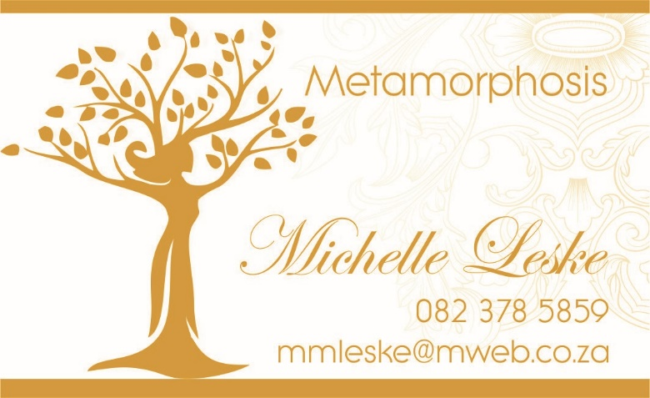
BOOKING FORM

PILGRIMAGE:
Goddess Tour to Egypt
22 November – 6 December 2018
Fill in details as they appear on your passport

TITLE | SURNAME | FIRST NAME | AGE

PASSENGER CONTACT DETAILS:
Full Name
Telephone No.
Mobile No.
Email address
Passport Number

Emergency Contact Details:
Name:
Telephone Number:
Mobile Number:
Relationship:

Preferred Accommodation: 1.Single 2.Sharing

The passengers’ signature below confirms that he/she has read and understood and accepted the Terms and Conditions and Payment details listed below.

I accept the terms fully and accept responsibility for payment of the account.

Name: _____________________________ Date: ____________________
Signature: _________________________

TERMS AND CONDITIONS
By making your reservation of any travel services offered by Metamorphosis, Airbus Tours and NIL-SEGELN you accept the Terms and Conditions stated below. Please ensure that you read carefully and understand these Terms & Conditions prior to confirming your booking.
These General Terms and Conditions govern the contractual relationship between you and Metamorphosis and Airbus Tours and NIL-SEGELN in respect of the package trips and other travel services we offer.
A package trip is defined as such when we arrange transport plus accommodation or another tourism service for a total price and the trip lasts for at least 24 hours or includes an overnight stay.
A contract is concluded once Metamorphosis and, Airbus Tours and NIL-SEGELN has accepted a booking you have made in writing (letter, e‐mail or via the Internet) or by telephone.
Metamorphosis, Airbus Tours and NIL-SEGELN and its agents and suppliers, in making arrangements for hotels, tours, meals, transportation or any service in connection with the itineraries of individual customers, shall not be liable for injury, damage, loss, accident, delay or irregularity, liability or expense to person or property due to act of default by any hotel, carrier or other company or person providing services included in the tours.
Furthermore, Metamorphosis, Airbus Tours and NIL-SEGELN its agents and suppliers accept no responsibility for any sickness, pilferage, labour disputes, machinery breakdown, government restrains, acts of war and/or terrorism, weather conditions, defect in any vehicle of transportation or for any misadventure or casualty or any other causes beyond their control.
Under no circumstances will Metamorphosis, Airbus Tours and NIL-SEGELN or its agents, affiliates, service providers, suppliers, and/or distributors be liable for any of the following losses or damage (whether such losses where foreseen, foreseeable, known or otherwise): (a) loss of data; (b) loss of revenue or anticipated profits; (c) loss of business; (d) loss of opportunity; (e) loss of goodwill or injury to reputation; (f) losses suffered by third parties; or (g) any indirect, consequential, special or exemplary damages arising from the use of Metamorphosis, Airbus Tours and NIL-SEGELN regardless of the form of action.

RESERVATION, CANCELLATION AND OTHER POLICIES
RESERVATION: A non-refundable deposit of US$500 is due with your reservation.
PAYMENTS: The deposit and other payments are to be made to Michelle Leske of Metamorphosis.
Failure to pay in time entitles Metamorphosis, Airbus Tours and NIL-SEGELN to cancel your booking without notice and without refund of the deposit. Prices are quoted in
US Dollars.

Cancellation Policy:
If you need to cancel a reservation, please do so in writing by e‐mail. If we receive your cancellation more than 45 days before the starting date of the trip, we refund 100% of your monies paid excluding the US$500 deposit.
Should you cancel:
45 days prior to the commencement of the tour – 30% of the Tour Cost will be non-refundable
44 – 30 days prior to the commencement of the tour – 50% of the Tour Cost will be non-refundable
29 – 15 days prior to the commencement of the tour – 80% of the Tour Cost will be non-refundable
14 days up to and including the start of the tour – the total payment will be forfeited
The tour price is quoted as a package. No partial refunds or credit will be given for services not used. We recommend that you obtain travel insurance upon booking.
EXCLUSION FROM TOUR PRICE: The following items are not included in the tour price: *International Flights *visa, passport and vaccination charges; *extra meals not included in the itinerary; *laundry, postage, personal clothing, medical expenses, personal travel insurance and items & services of a personal nature; *emergency evacuation charges.

Payment information:
A non-refundable deposit of US$500 is payable on booking
Per Person Sharing Single Room
a Double Room (Supplement)
Payment Date Amount Amount
Deposit on Booking US$ 500 US$ 500
31 May 2018 US$ 458 US$ 528
30 June 2018 US$ 458 US$ 528
31 July 2018 US$ 458 US$ 528
31 August 2018 US$ 458 U$ 528
1 October 2018 US$ 458 US$ 528
Tipping to be paid
On arrival in Egypt US$ 200 US$ 200
TOTAL US$2990 (including deposit) US$3340 (including deposit)

Payments are to be made to:

My PayPal account: mmleske@mweb.co.za (You may use this account if you wish to make payments using your credit card). Please add 4% if you are using this payment method.

Or into my banking account below:

M. Leske
FirstRand Bank Limited (First National Bank for South Africans)
Cheque Account
Account Number: 626 6595 3438
Branch code: 250655
Swift Code Number: FIRNZAJJ

